Usability and Efficacy of Augmented Reality for Paramedic Procedural Skills Education

Ivette Motola, MD, MPH
Michael S. Gordon Center for Research in Medical Education
University of Miami Miller School of Medicine

Angel Brotons, EMT-P
Michael S. Gordon Center for Research in Medical Education
University of Miami Miller School of Medicine

Robert Levine, MD
ArchieMD

Richard Rodriguez, MA
Michael S. Gordon Center for Research in Medical Education
University of Miami Miller School of Medicine

S. Barry Issenberg, MD
Michael S. Gordon Center for Research in Medical Education
University of Miami Miller School of Medicine

Contents
List of Tables Error! Bookmark not defined.ii
List of Figures iv
Introduction 1
Overview 1
Background and Rationale 1
Study Design and Methods 3
Design/Study Type 3
Objectives 3
Selection of Instruments 4
Intervention………………… ………………………………………………………………………………………………………………...... 5
Description of Study Process 9
Administration of Instruments 9
Intervention / Demonstration 9
Statistical Analysis 9
Primary and Secondary Endpoints 9
Sample Size 10
Results 10
Demographics 10
Computer Use 11
Use of Simulation and Interactive Medical Education Software 12
Experience with Cricothyrotomy and Needle Thoracostomy………………………………………………………… 13
Participant Survey 14
Section 1. Surgical Cricothyrotomy 14
Section 2. Needle Thoracostomy 15
Section 3. Open-Ended Questions 15
Skills Assessments……………………………………………………………………………………………………………………………… 16
Discussion 16
Conclusion 17
References 18

List of Tables
Table 1. Age of participants 10
Table 2. Sex distribution of participants 10
Table 3. Race and ethnicity of subjects 10
Table 4. Hours per week of computer use 11
Table 5. Length of time of computer use 11
Table 6. Level of understanding about computers 12
Table 7. Attitudes about computers and expertise 12
Table 8. Use of simulation and interactive software 12
Table 9. Number of observed and performed cricothyrotomies and needle thoracostomies 13
Table 10. Hours of instruction in cricothyrotomy and needle thoracostomy 13
Table 11. Level of comfort with performing cricothyrotomy and needle thoracostomy 13
Table 12. Types of previous training in cricothyrotomy and needle thoracostomy 14
Table 13. Surgical Cricothyrotomy results summary 14
Table 14. Needle Thoracostomy results summary 15
Table 15. Skills assessment results for cricothyrotomy 16
Table 16. Skills assessment results for needle thoracostomy 16

List of Figures
Figure 1. Paramedic completing cricothyrotomy procedure. 6
Figure 2. Antero-posterior anatomy of thyroid cartilage, cricoid cartilage and cricothyroid membrane for cricothyrotomy procedure.. 7
Figure 3. Sagittal cross-sectional anatomy as endotracheal tube is inserted for cricothyrotomy procedure. 7
Figure 4. Antero-posterior view of the chest with superimposed anatomy demonstrating a right pneumothorax 8
Figure 5. Anatomic landmarks and localization for needle insertion in needle thoracostomy 8
Figure 6. Weekly Computer Use Graph. 11

Introduction
The overall aim of this pilot study was to determine the efficacy of the Augmented Reality Trainer in promoting skills gain among paramedics. We evaluated the augmented reality devices for training paramedics in two critical procedures: surgical cricothyrotomy and needle thoracostomy. ArchieMD developed the technology based on a human manikin task trainer combined with 2D and 3D anatomic visual models presented on a screen. Voice prompts and optical sensors allow integration of the medical equipment with the anatomic models and the manikin while the procedures are being conducted. This results in a realistic patient anatomic and physiologic representation.
Paramedics participated in a didactic session that incorporated a demonstration of the technology. The evaluation of the augmented reality technology included pre and post skills assessment, and qualitative feedback. The evaluation also included feasibility testing to determine educational benefits and any barriers when using the technology. In addition, we developed a questionnaire to collect data on the usability of the interface itself (e.g., how easy it is to use, how engaging it is, any challenges associated with its use, etc.).

Overview
This evaluation seeks to determine the effectiveness and usability of augmented reality devices for teaching paramedics two procedural skills: 1) surgical cricothyrotomy and 2) needle thoracostomy. We measured the effectiveness of the intervention by conducting pre and post skills assessments of each procedure. We collected data using baseline and post-intervention surveys to determine the paramedics’ reactions to using the technology for education, and to identify possible benefits and barriers to its use. The data will provide important feedback for refinement of the technology, and will provide evidence for its usability and effectiveness in paramedic training.

Background and Rationale
Historically, clinical procedures were taught at the bedside on actual patients, or in simulated environments using cadavers, animal models and more recently, human patient simulators and task trainers. Patient safety and animal rights concerns, coupled with the challenge to determine the optimal learning environment and training modalities, have prompted the medical education research community to devise new and innovative ways to teach, practice and assess clinical procedures. Augmented reality (AR) technology is an innovation that merges digitally created images with real objects such as simulation manikins to improve the visualization of anatomy during the learning process, and also to provide realistic haptic (touch) feedback that is missing from purely virtual reality simulators (Botden, Buzink, Schijven, & Jakimowicz, 2007) (Ellaway, 2010). Additionally, optical sensors enable tracking of the movements of the learner and equipment, leading to visualization of devices and cross-sectional anatomy during the procedure. Correct and incorrect technique and positioning can be identified and corrected during practice.
More than fifty years ago, Bloom reported that most teaching focused on the lowest levels of training (fact-transfer and information recall), rather than on true personal development in which the focus is on mastery of subjects and promotion of higher levels of thinking (Bloom, Engelhart, Furst, Hill, & Kartwihl, 1956). Determining the best methods for teaching and learning continues to be a challenge for medical educators. The goal in teaching psychomotor skills is to have the learner reach a point of automation that leads them closer to becoming an expert. Learners must progress, however, through the levels of imitation, manipulation, developing precision and articulation.
Over the past two decades, there has been an increase in the use of technology-enhanced educational methodologies in military and civilian healthcare training. In healthcare, the greatest growth has occurred in multi-media learning and human patient simulator training. Several factors have converged to cause the increase use of clinical simulation across the education continuum from undergraduate to continuing education. These include an increased focus on patient safety, the need for a new training model not based solely on apprenticeship, the drive for standardized educational opportunities with on-demand access to “patients,” and a need to practice and hone skills in a controlled environment. At the same time, the benefits of clinical simulation are increasingly demonstrated, adding further validity to its use in healthcare education (Issenberg, McGaghie, Petrusa, Gordon, & Scalese, 2005). Increasingly, there is evidence that technology-enhanced simulation training in health professions education has a large positive impact on knowledge, skills, and behaviors, as well as translation to the clinical setting and improved patient outcomes (Cook, et al., 2011).
Technology has been used by the military to provide initial, ongoing and just-in-time training to healthcare providers using various tools including simulation, virtual reality, telemedicine, and e-learning. Fried and colleagues describe how VR simulators have been used very effectively to train military and commercial pilots (Fried et al., 2005), and state that there is similar promise in the medical field. In surgery, computer-assisted devices have been an increasing part of surgical resident education and training for the past three decades. Walker et al. describe “virtual laryngoscopy” training of deployed military medical personnel using a combination of video conferencing and video laryngoscopy equipment (Walker RB et al. 2012).
Virtual reality (in which computers create realistic environments) has been credited with revolutionizing the way we learn and perhaps even live, but its use has been limited in medical education (Rheingold, 1992). Ellaway describes the limitations as resulting from differences in actions and responses, rendering the environments useless beyond some predefined events and broad gestures. Avatars (virtual humans) have a preset list of actions and motions, making them appear robotic and unrealistic. Another limitation is that the haptic feedback in laparoscopic simulation is less realistic using a VR simulator (LapSim VR) as compared with an AR simulator (ProMIS AR) (Botden, Buzink, Schijven, & Jakimowicz, 2007) (Botden & Jakimowicz, 2009). Augmented reality using digitally generated overlays on real objects, such as a human patient simulator, bridges this gap in realistic haptic feedback found in virtual reality immersive environments.
There is minimal literature on the use of AR for learning clinical procedures beyond laparoscopy training. In this study, we will evaluate practicing paramedics’ reactions to incorporating AR simulation into surgical cricothyrotomy and needle decompression skills training. Determining the effectiveness and usability of this modality for paramedic education will guide the development of the technology and its integration into a skills curriculum.

Study Design and Methods
We recruited the study population for this evaluation from practicing paramedics from four South Florida fire-rescue departments. Participants for this study were volunteers. The study was submitted for approval to the University of Miami Institutional Review Board, which reviewed the consent form and all instruments and communications with the participants. The study was approved under Exempt status as an educational intervention.
The Principal Investigator and Research Assistant informed participants of the study and invited them to participate. The Research Assistant obtained informed consent. He gave participants a description of the study and the opportunity to opt out of participation. We assigned each subject a specific study identification number to maintain anonymity in data collection. Following the consent process, we administered a baseline questionnaire inquiring about participant familiarity with computers, and use of simulation and interactive medical software in their training. We also asked participants to answer questions about their previous training in cricothyrotomy and needle thoracostomy, and the number of procedures they had observed or performed on patients.
After completing the baseline questionnaires, we assessed participants while they performed each procedure (Figure 1). We used checklists adapted from the paramedic national standards, and for which we had previously demonstrated validity evidence during our airway course. Raters, whom we trained in the use of the checklists, consisted of physician and paramedic faculty at the University of Miami Gordon Center for Research in Medical Education. Each participant performed cricothyrotomy and needle decompression after a brief introduction to the simulation manikins and equipment.

Design/Study Type

Objectives
This educational evaluation seeks to determine whether the augmented reality technology:
- Is well received by paramedics as a learning adjunct
- Has perceived additional benefit to current procedural skills education
- Poses any barriers to use in procedural skills education
- Is effective in a demonstration setting for teaching procedures
This evaluation/study design has two components: a qualitative attitudes study, and an effectiveness study to evaluate skills improvement. We utilized a baseline questionnaire to measure computer use, to document previous experience with the procedures being taught, and to collect demographic information. We assessed skill proficiency before and after the educational intervention. Finally, we administered a survey after the intervention to measure participants’ reactions and perceived benefits and barriers to use of the technology for procedural skills training.

Selection of Instruments

We developed four instruments for this evaluation. The first instrument was a Baseline Participant Survey to measure the participants’ level of comfort and expertise with computers, and the use of simulation and interactive software in their medical education. We included items to record the participants’ prior experience with the procedures, and to gather demographic information. The post-demonstration survey assessed participants’ attitudes towards the technology using 5-point Likert scale questions and open-ended questions.
We adapted the items on computer use from previously developed instruments. Cork and colleagues undertook an extensive review of prior psychometric studies of physician attitudes towards computers, in order to develop and validate an instrument to measure “physicians’ use of, knowledge about and attitudes towards computers” (Cork, Detmer, & Friedman, 1998). Although their questionnaire was more exhaustive, we adapted their items for similar measures. Additionally, we incorporated the EDUCAUSE Center for Applied Research questionnaire on student information technology use in higher education for item development (Smith S, 2010). Finally, an expert in evaluation/measurement techniques reviewed the instrument and provided feedback for further revision.
The final instrument consisted of 31 items divided into four sections.
Section 1: Computer Experience and Use. Number of hours of computer use per week, how long they have been using computers, and self-rated level of expertise with computers. Additional questions used a 5-point Likert scale to self-rate computer sophistication (ease of use of computers, enjoy learning new software, give more advice than receive on computer use).
Section 2: Use of Simulation and Interactive Medical Software. This section was comprised of 5 items to document previous use of patient simulators, medical software, virtual reality and augmented reality in paramedic training.
Section 3: Previous Experience with Procedures. This section consisted of 14 items to record the participants’ prior experience with the cricothyrotomy and needle thoracostomy. Items included the number of procedures they had observed or performed on patients, and their previous training in each procedure.
Section 4: Demographics. Participant age, gender, race and ethnicity were obtained in this section.
We adapted the checklists used to assess the paramedics’ skills from previous tools we had used for our Airway Management course. A team of experts (emergency physicians, paramedics, psychometricians) developed this instrument and incorporated national requirements for competency in the procedures as set by the National Registry of Emergency Medical Technicians (NREMT). The checklists items reflected each step of the procedure and were dichotomous (yes/no) indicating the participant had either performed the step correctly or had not. We provided space for additional written comments to capture anything unexpected that might arise.
The survey we administered after the demonstration and education session assessed the paramedics’ reactions to the use of augmented reality simulation for procedural skills teaching and learning. We modeled the instrument after previous published usability surveys that assessed e-Learning and augmented reality. Zaharias and Sandars describe systematic approaches to developing tools for usability testing in e-Learning (Zaharias & Poylymenakou, 2009) (Sandars & Lafferty, 2010). We evaluated other usability instruments including Botden and colleagues’ assessment of augmented versus virtual reality laparoscopic simulation, and Pierce and colleagues’ comparative usability study of full versus partial immersive virtual reality simulation in medical education and training (Botden, Buzink, Schijven, & Jakimowicz, 2007) (Pierce, et al., 2008). An expert in evaluation/measurement techniques evaluated the instrument and provided feedback that was incorporated into the revised version.
The final instrument consisted of 23 items. The last five questions were open-ended, and we allotted additional time to participants to complete these. The first two sections were divided into the two procedures assessed. Each section started with a question about the realism of the anatomy and whether it helped in identifying landmarks. This was followed by a series of questions on the technology and learning, followed by questions on satisfaction. The open-ended questions inquired about specific features that the participant liked, the areas that needed improvement, barriers to incorporating the technology into paramedic education, and the aspects of augmented reality that were most helpful to learning.
We provided the following instruction to the participants for completing the questionnaire:
“This questionnaire is composed of a series of statements about your personal attitudes about use of and experience with the Augmented Reality technology. Each item represents a statement about your satisfaction with learning. There are no correct or incorrect answers. Please indicate your own feelings about each statement below by marking the number that best describes your attitude or belief. Please be truthful and describe your attitude as it really is, not what you would like for it to be. This is anonymous, with the results being compiled as a group, not individually. If you have any questions or concerns, please let the research assistant know.”
Intervention
Study subjects participated in a one-hour instructional session using augmented reality to teach cricothyrotomy and needle thoracostomy. Participants performed the techniques on manikins specially outfitted to be able to include virtual reality anatomy and device tracking on a large monitor positioned in front of the classroom.
For the cricothyrotomy procedure, the participants visualized the antero-posterior airway anatomy superimposed on the manikin while the instructor outlined the steps of locating anatomical landmarks, making skin and cricothyroid membrane incisions (Figure 2). Once the trachea was accessed, the view was changed to a cross-sectional sagittal view of the neck airway anatomy, and the participants could observe the endotracheal tube (ETT) being advanced into the trachea (Figure 3). Two different scenarios were presented - correct surgical cricothyrotomy, and incorrect placement of the ETT in the anterior subcutaneous tissues.
The needle thoracostomy procedure began with examination of the simulated patient (manikin) and determination that there were decreased breath sounds on the affected side, consistent with a tension pneumothorax. The participants could visualize the collapsed, non-expanding lung with respiration (Figure 4) and then identify the anatomic landmarks of the upper chest. The clavicle and ribs were visible on the screen as they were identified. We marked the needle and it could be visualized as it was inserted into the second intercostal space (Figure 5). Two scenarios were presented - correct needle thoracostomy, and lateral insertion of the needle into the soft tissues of the thorax.
After both procedures were completed, we administered the participant surveys. The questionnaire gathered participants’ attitudes about the technology, using Likert scales as well as specific open-ended questions.
We instructed participants to individually perform each procedure while being assessed using the same standardized checklists utilized in the pre-intervention assessment.
Once the session was completed, the data were compiled, entered into the IBM SPSS Statistics 19 program, and analyzed. We compiled descriptive statistics from the usability questionnaires. We used logistic regression to determine any association between computer use and participant assessment of the technology.

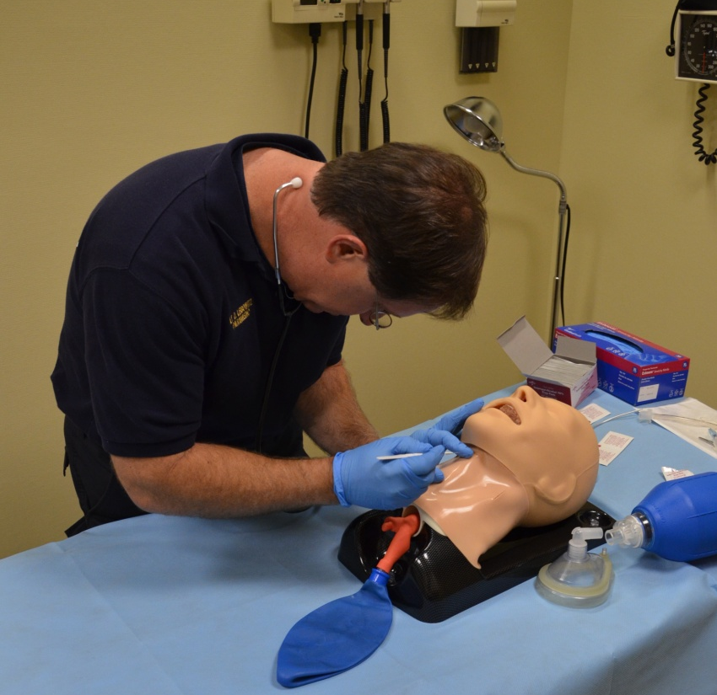
Figure 1. Paramedic completing cricothyrotomy procedure.

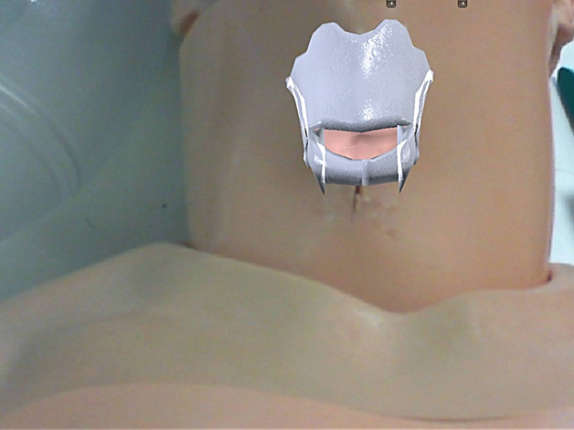
Figure 2. Antero-posterior anatomy of thyroid cartilage, cricoid cartilage and cricothyroid membrane for cricothyrotomy procedure.

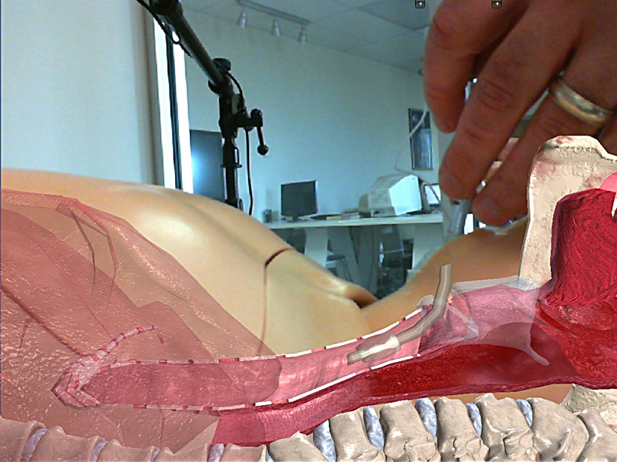
Figure 3. Sagittal cross-sectional anatomy as endotracheal tube is inserted for cricothyrotomy procedure.

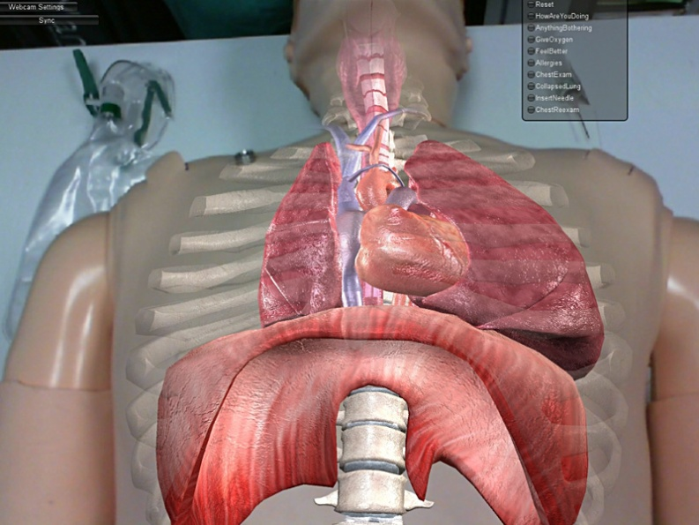
Figure 4. Antero-posterior view of the chest with superimposed anatomy demonstrating a right pneumothorax.

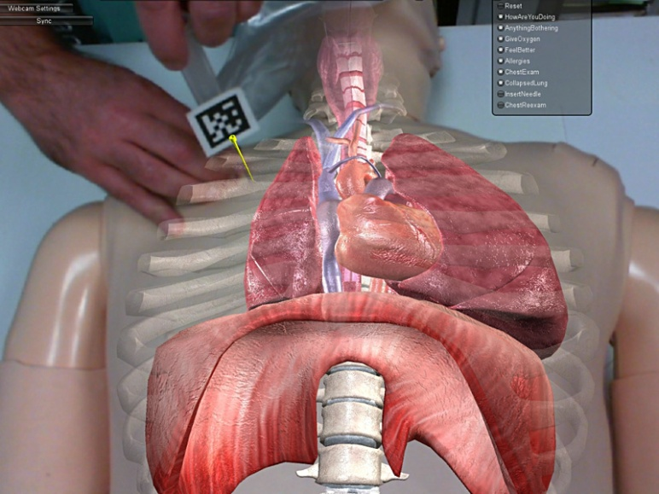
Figure 5. Anatomic landmarks and localization for needle insertion in needle thoracostomy.

Description of Study Process

Administration of Instruments
We administered the baseline participant survey after we obtained informed consent and prior to the educational session using the augmented reality technology. We administered the usability questionnaire after completion of both procedure demonstrations. The surveys were pre-numbered with the participant’s randomly selected identification number, and participants completed these anonymously.

Pre-intervention and Post-intervention Skills Assessments
After completing the baseline questionnaire, participants went to a room where they performed a cricothyrotomy on a simulation task trainer, and then proceeded to another room to perform a needle thoracostomy. They had a maximum of 5 minutes for each procedure to become acquainted with the equipment and to perform the procedure. A trained rater (physician or paramedic faculty) was in the room and completed the checklist. The same procedure was followed after the educational intervention using AR demonstration of each procedure.

Intervention / Demonstration
We performed the demonstrations after the paramedics completed the pre-intervention assessments. Two simulation manikins were set-up with the AR technology in the front of the room. The anatomical landmarks and devices were visualized on a large screen in front of the classroom and superimposed on the manikins (See Figure 2). First, we demonstrated the cricothyrotomy procedure, and the instructor proceeded through correct and incorrect procedures. We used vocal prompts for both instruction and to alert the computer what to show next on the screen. The needle thoracostomy demonstration followed, and it focused on identification of anatomical landmarks and correct needle insertion into the second intercostal space right over the third rib. We also demonstrated incorrect placement into the lateral chest wall.

Statistical Analysis

Primary and Secondary Endpoints
We evaluated the augmented reality technology for its use in teaching paramedics procedural skills. At this point in the technology’s development, the paramedics participated as observers in a demonstration / didactic session. Participants’ reactions to the technology were assessed for usefulness in learning and any perceived barriers to use. The data were entered into IBM SPSS Statistics 19 and we used descriptive statistics for analysis. We report the mode, the mean, and the standard deviation for all Likert scale questions. Statistical significance was set at the 0.01 level. Additionally, we performed an ordinal logistic regression to determine whether previous computer use or simulation-based training impacted the participants’ perceptions of the AR technology.

Sample Size
The sample size in this study was purposely kept small due to the nature of the demonstration and set-up of the technology. The initial goal was to recruit 20 paramedics.

Results
A total of 12 paramedics enrolled in the study and completed baseline and post-intervention questionnaires.
Tables 1 –3 provide a demographic breakdown of the group.

Demographics

n | Mean Age | Range | SD
11* | 39.91 | 27-54 | 9.33
Table 1. Age of participants (* one participant did not complete the question)

Sex | n | Percent (%)
Male | 12 | 100.0
Female | 0 | 0.0
Table 2. Sex distribution of participants

Race | n | Percent (%)
Caucasian | 8 | 66.7
Black | 1 | 8.3
Asian or Pacific Islander | 0 | 0.0
Other | 2 | 16.7
Not Reported | 1 | 8.3
Ethnicity | n | Percent (%)
Hispanic | 5 | 41.7
Not Hispanic | 7 | 58.3
Table 3. Race and ethnicity of participants

Computer Use

Tables 4-6 and Figure 4 summarize use of and familiarity with computers. Table 7 includes three additional questions about the participants’ attitudes towards computers. A 5-point Likert scale was used where 1= Strongly Disagree, 2=Disagree, 3=Unsure, 4=Agree, and 5= Strongly Agree.

Item | 0 | 1-5 | 6-10 | 11-20 | 21-30 | > 30
How many hours per week do you use a computer? | 0 (0%) | 5 (41.7%) | 2 (16.7%) | 2 (16.7%) | 1 (8.3%) | 2  (16.7%)
Table 4. Hours per week of computer use

Figure 6. Weekly computer use graph

Item - How long have you been using a personal computer? | n | Percent (%)
< 1 year | 0 | 0.0
1-2 years | 0 | 0.0
2-5 years | 1 | 8.3
5-10 years | 4 | 33.3
> 10 years | 7 | 58.3
Table 5. Length of time of computer use

Item – Which statement below best describes your level of understanding about computers? | Frequency | Percent (%)
I know the basics of how to use my PC, but not much more. | 4 | 33.3
I understand how to use most of my software, and have little trouble learning new software. | 6 | 50.0
I completely understand my PC software and hardware. | 2 | 16.7
I consider myself an expert with computers. | 0 | 0.0
Table 6. Level of understanding about computers

Use of Computers | Mode | Mean | SD
I find computers extremely easy to use. | 4 | 3.58 | 1.08
I really enjoy learning new computer software. | 4 | 3.33 | 1.30
I give more computer advice to other people than I receive. | 1 & 2 | 2.33 | 1.37
Table 7. Attitudes about computers and perceived level of expertise

Use of Simulation and Interactive Medical Education Software
We also assessed the participants’ previous use of simulation, virtual reality, augmented reality and interactive medical education software in the baseline questionnaire. Responses were provided on a 5-point Likert scale where 1= Strongly Disagree and 5= Strongly Agree.

Use of Simulation and Interactive Software | Mode | Mean | SD
I have used interactive patient simulators in my training. | 3 | 2.64 | 1.21
I have used interactive medical education software in my training. | 4 | 2.75 | 1.36
I have used virtual reality in my training. | 1 | 1.33 | 0.65
I have used augmented reality in my training. | 1 | 1.08 | 0.29
I have performed procedures on a simulator in my training. | 4 | 3.42 | 0.90
Table 8. Use of simulation and interactive software

Experience with Cricothyrotomy & Needle Thoracostomy
We obtained prior experience with both procedures using the baseline questionnaire. We asked participants a series of questions regarding the number of observed and performed cricothyrotomies and needle thoracostomies and the number of hours of instruction they had received in the procedures.

Item | 0 | 1 | 2-3 | 3-5 | 5-10 | > 10
About how many cricothyrotomies have you observed being performed? | 5 (41.7%) | 3  (25.0%) | 3 (25.0%) | 0 (0.0%) | 1 (8.3%) | 0 (0.0%)
About how many cricothyrotomies have you performed on patients? | 9 (75.0%) | 3 (25.0%) | 0 (0.0%) | 0 (0.0%) | 0 (0.0%) | 0 (0.0%)
About how many needle thoracostomies have you observed being performed? | 4 (33.3%) | 3 (25.0% | 3 (25.0%) | 1 (8.3%) | 1 (8.3%) | 0 (0.0%)
About how many needle thoracostomies have you performed on patients? | 9 (75.0%) | 2 (16.7%) | 1 (8.1%) | 0 (0.0%) | 0 (0.0%) | 0 (0.0%)
Table 9. Number of observed and performed cricothyrotomies and needle thoracostomies

Item | 0 | 1 | 2 | 3-5 | > 5
About how many hours of instruction have you received in performing a cricothyrotomy? | 0 (0.0%) | 4 (33.3%) | 3 (25.0%) | 3 (25.0%) | 2 (16.7%)
About how many hours of instruction have you received in performing a needle thoracostomy? | 0 (0.0%) | 4 (33.3%) | 3 (25.0%) | 2 (16.7%) | 3 (25.0%)
Table 10. Hours of instruction in cricothyrotomy and needle thoracostomy

Item – Which statement below best describes your level of comfort with performing a… | Frequency | Percent (%)
Cricothyrotomy
I am not at all comfortable. | 1 | 8.3
I am somewhat comfortable. | 10 | 83.3
I am very comfortable. | 1 | 8.3
I consider myself an expert. | 0 | 0.0
Needle Thoracostomy
I am not at all comfortable. | 2 | 16.7
I am somewhat comfortable. | 8 | 66.7
I am very comfortable. | 2 | 16.7
I consider myself an expert. | 0 | 0.0
Table 11. Level of comfort with cricothyrotomy and needle thoracostomy

Item | Never | 1-2 times | 2-5 times | > 5 times
I have observed a video on the cricothyrotomy procedure. | 3 (25.0%) | 4 (33.3%) | 5 (41.7%) | 0 (0.0%)
I have opened and been oriented to the contents of a cricothyrotomy kit. | 1 (8.3%) | 6 (50.0%) | 2 (16.7%) | 3 (25.0%)
I have practiced performing a cricothyrotomy on a simulation mannequin. | 3 (25.0%) | 5 (41.7%) | 2 (16.7%) | 2 (16.7%)
I have observed a video on the needle thoracostomy procedure. | 4 (36.4%) | 2 (18.2%) | 4 (36.4%) | 1 (9.1%)
I have opened and been oriented to the contents of a needle thoracostomy kit. | 0 (0.0%) | 4 (36.4%) | 5 (45.5%) | 2 (18.2%)
I have practiced performing a needle thoracostomy on a simulation mannequin. | 3 (27.3%) | 2 (18.2%) | 3 (27.3%) | 3 (27.3%)
Table 12. Types of training in cricothyrotomy and needle thoracostomy

Participant Survey

Section 1. Surgical Cricothyrotomy
We asked participants to rate nine statements using a 5point Likert scale where 1= Strongly Disagree and 5= Strongly Agree. The mode, mean and standard deviation are reported below.

Surgical Cricothyrotomy | Mode | Mean | SD
The anatomy was realistic and helped me identify landmarks. | 5 | 4.58 | 0.52
The technology helped improve my learning of this procedure. | 5 | 4.58 | 0.52
This technology offered features that supported learning. | 5 | 4.67 | 0.49
The technology incorporates interactivity to gain my attention and motivate you to learn. | 5 | 4.83 | 0.39
The technology incorporated novel features that motivated me to learn. | 5 | 4.75 | 0.45
The technology was enjoyable to use and interesting. | 5 | 4.67 | 0.49
I see this technology as a useful tool in my procedure skills training. | 5 | 4.83 | 0.39
The demonstration of the technology was useful. | 5 | 4.83 | 0.39
Incorporating the modality into skills education would be useful. | 5 | 4.75 | 0.45
Table 13. Surgical Cricothyrotomy results summary

Section 2. Needle Thoracostomy
We asked participants to rate nine statements using a 5-point Likert scale where 1= Strongly Disagree and 5= Strongly Agree. The mode, mean and standard deviation are reported below.

Needle Thoracostomy | Mode | Mean | SD
The anatomy was realistic and helped me identify landmarks. | 5 | 4.58 | 0.52
The technology helped improve my learning of this procedure. | 5 | 4.58 | 0.52
This technology offered features that supported learning. | 4 & 5 | 4.50 | 0.52
The technology incorporates interactivity to gain your attention and motivate me to learn. | 5 | 4.67 | 0.65
The technology incorporated novel features that motivated me to learn. | 5 | 4.67 | 0.49
The technology was enjoyable to use and interesting. | 5 | 4.67 | 0.49
I see this technology as a useful tool in my procedure skills training. | 5 | 4.58 | 0.67
The demonstration of the technology was useful. | 5 | 4.83 | 0.39
Incorporating the modality into skills education would be useful. | 5 | 4.75 | 0.45
Table 14. Needle Thoracostomy results summary

An ordinal logistic regression analysis did not reveal any significant association between computer use and reactions to the technology, although the small sample size may have impacted our ability to detect an association.

Section 3. Open-Ended Questions

We asked participants a series of open-ended questions in the third section of the survey. They were given time and encouraged to fill these out. We coded and categorized the responses. The summary follows below, indicating the number of participants who responded with the same theme.
Question 1. What specific features did you like best about using the Augmented Reality technology?
Theme: Anatomic overlay / Ability to see anatomical landmarks / Visualization [8 of 12 responding]
Question 2. What areas do you think need to be improved and why?
Theme: None / Not much [6 of 12 responding]
Question 3. What barriers do you see to incorporating this technology into medical education?
Theme: Cost [8 of 12 responding]
Question 4. Describe what aspects of the AR technology were the most helpful to your learning.
Theme: Visualization of the anatomy (8 of 12 responding)
Question 5. Any other comments or suggestions?
- Great technology / tool / class / experience (4 of 12 responding)

Skills Assessments

Surgical Cricothyrotomy

Surgical Cricothyrotomy | Mean
Precourse Assessment | 61.63%
Postcourse Assessment | 80.02%
P value | < 0.01
Table 15. Skills Assessment Results for Surgical Cricothyrotomy

Needle Thoracostomy

Needle Thoracostomy | Mean
Precourse Assessment | 88.77%
Postcourse Assessment | 99.07%
P value | < 0.01
Table 16. Skills Assessment Results for Needle Thoracostomy

Discussion
The purpose of this study was to evaluate paramedics’ reactions to procedural skills training using augmented reality, and to determine if an educational intervention using the technology had an impact on skill acquisition. We focused on cricothyrotomy and needle thoracostomy - modules developed and tested by ArchieMD. In addition, paramedics are required to learn and show proficiency in these procedural skills as part of their training and professional credentials.
Twelve subjects were recruited from four South Florida fire rescue departments. The paramedics participated voluntarily. The mean age of the participants was 39.9 years old with a range from 27 to 54. The group was composed of 100% males. The group was diverse and represented multiple races.
The baseline computer use questionnaire revealed that the greatest proportion of participants (41.7%) spent on average 1-5 hours a week using a computer, with the remainder spending from 6 to more than 30 hours per week using computers. The majority of participants (58.3%) had been using a computer for more than 10 years, reflecting a group of digital natives. No paramedic identified himself as a computer expert, and 4 paramedics stated they knew the basics of their computer but not much more. The majority of participants (66.7%) said they understand their computer software and have little trouble learning new software, or that they completely understand software and hardware.
Participants had used some interactive medical education software and patient simulators in their training, but only one had used any augmented or virtual reality. Only one-third of participants had performed procedures on a simulator as part of their training.
The skills assessments revealed that the educational intervention resulted in statistically significant improvement in paramedic performance of surgical cricothyrotomy and needle thoracostomy. The greatest improvement was in surgical cricothyrotomy, where the mean percentage of correct steps increased from 61.63% to 80.02% (p value < 0.01). For needle thoracostomy, the mean improvement was 88.77% to 99.07% (p value < 0.01)
The post-intervention survey revealed that paramedics had a positive reaction to the augmented reality technology and its use in education. Ratings were about equivalent for both procedures, and almost all questions had a mode of 5 (strongly agree). Participants thought that AR was a useful tool in procedural skills training, that the demonstration was useful, and that it aided them in improving the learning of the procedures. Paramedics rated highest the ability to see anatomical structures and landmarks as the instructor was performing the procedure, and found this to be the feature most helpful to their learning. They indicated that expense would be the primary barrier to incorporating the technology in their education.
Finally, a significant limitation in the current study was the relatively passive experience of the learners during the procedure demonstrations. It is likely that active, deliberate practice of the skills using AR would result in even higher ratings of the perceived usefulness of the technology to acquire these skills. However, the demonstration resulted in significant improvement of both skills as performed by the paramedics before and after the educational intervention.

Conclusion
This pilot study demonstrated that paramedics improved their procedural skills in surgical cricothyrotomy and needle thoracostomy, and that they rated augmented reality useful in learning both procedures. They agreed that incorporating the technology into their education would be helpful in their training. The feature they found most useful was the ability to see anatomical structures and landmarks. The cost of acquiring enough models to allow for use by many students was the most commonly raised concern.
The next phase of development should include the ability for the augmented reality technology to operate while students are practicing on the simulation manikins. Future efforts should include a larger experimental study with a larger, more diverse sample population to determine whether using the augmented reality technology in procedural skills education improves student skills acquisition as compared to traditional education.

References
American Psychological Association. (1999). Standards for Educational and Psychological Testing.
Bloom, B., Engelhart, M., Furst, E., Hill, W., & Kartwihl, D. (1956). Taxonomy of educational objectives: the classification of educational goals. New York: Longmans, Green.
Botden, S., & Jakimowicz, J. (2009). What is going on in augmented reality simulation in laparoscopic surgery? Surg Endosc , 23:1693-1700.
Botden, S., Buzink, S., Schijven, M., & Jakimowicz, J. (2007). Augmented versus virtual reality laparoscopic simulation: what is the difference? World J Surg , 31:764-772.
Brodie, K. (1992). Scientific Visualization. Berlin: Springer-Verlag.
Cook, D., Hatala, R., Brydges, R., Zendejas, B., Szostek, J., Wang, A., et al. (2011). Technology-enhanced simulation for health professions education: a systematic review and meta-analysis. JAMA , 306(9):978-88.
Cork, R., Detmer, W., & Friedman, C. (1998). Development and Initial Validation of an Instrument to Measure Physician's Use of, Knowledge about, and Attitudes Towards Computers. J Am Med Inform Assoc , 164-176.
Ellaway, R. (2010). Augmented Reality. Med Teach , 32:791-793.
Gagné, R. (1985). The Conditions of Learning. 4th ed. New York: Holt, Rinehart, & Winston.
Gordin, D., & Pea, R. (1995). Prospects for scientific visualization as an educational technology. J. Learn. Sci , 4, 249-279.
Issenberg, S., McGaghie, W., Petrusa, E., Gordon, D., & Scalese, R. (2005). Features and used of high-fidelity medical simulations that elad to effective learning: A BEME systematic review. Med Teach , 27(1):10-28.
NHTSA. (2008). www.ems.gov/pdf/EMSWorkfoceReport_June2008.pdf. Retrieved 10 10, 2010, from EMS.GOV.
Pierce, J., Gutierrez, F., Vergara, V., Alverson, D., Qualls, C., Saland, L., et al. (2008). Comparative usability studies of full versus partial immersive virtual reality simulation for medical eductaion and training. Stud Health Technol Inform , 372-377.
Rheingold, H. (1992). Virtual Reliaty: The Revolutionary Technology of Computer-Generated Artificial Worlds- and How it Promises to Transform Society. New York: Simon and Schuster.
Rieber, L. (1994). Computers, Graphics, and Learning. Madison, WI: Brown and Benchmark.
Sandars, J., & Lafferty, N. (2010). Twelve tips on usability testing to develop effective e-learning in medical education. Med Teach , 32:956-960.
Smith S, C. J. (2010). The ECAR Study of Undergraduate Students and Information Technology, 2010 (Research Study, Vol. 6). Boulder, CO: EDUCAUSE Center for Applied Research, 2010, available from http://www.educause.edu/ecar.
Zaharias, P., & Poylymenakou, A. (2009). Developing a usability evaluation method for e-Learning applications: beyond functional usability. Intl Journal of Human-Computer Interaction , 25(1):75-98.

